**DISTANCE MEASUREMENT USING ULTRASONIC SENSOR (HC-SR04) AND ARDUINO**

**Description:**

The HC-SR04 ultrasonic sensor uses sonar to determine distance to an object. It offers excellent non-contact range detection with high accuracy and stable readings in an easy-to-use package. From 2cm to 400 cm or 1” to 13 feet. It operation is not affected by sunlight or black material like Sharp rangefinders are (although acoustically soft materials like cloth can be difficult to detect). It comes complete with ultrasonic transmitter and receiver module.

**Circuit Diagram:**

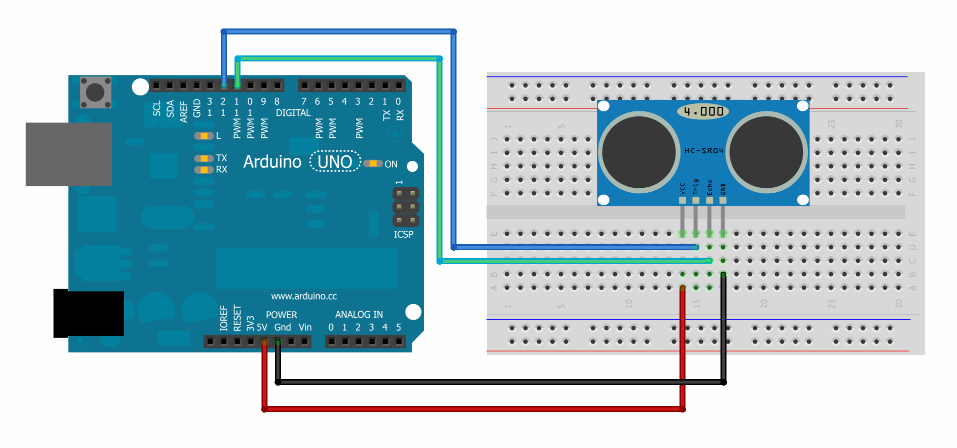

**Components Required:**

* Arduino Uno
* Ultrasonic Sensor(HC-SR04)
* Connecting Wires

**Specifications (HC_SR04):**

* Power Supply :+5V DC
* Quiescent Current : <2mA
* Working Current: 15mA
* Effectual Angle: <15°
* Ranging Distance : 2cm – 400 cm/1" - 13ft
* Resolution : 0.3 cm
* Measuring Angle: 30 degree
* Trigger Input Pulse width: 10uS
* Dimension: 45mm x 20mm x 15mm

**Ultrasonic Sensor Code:**

#define trigPin 12

#define echoPin 11

#define led 9

#define led2 10

void setup ()

{

Serial.begin(9600);

pinMode(trigPin, OUTPUT);

pinMode(echoPin, INPUT);

pinMode(led, OUTPUT);

pinMode(led2, OUTPUT);

Serial.print("Ultrasonic Sensor Starting!!!");

Serial.println("");

delay(1000);

}

void loop ()

{

int duration, distance;

digitalWrite(trigPin, HIGH);

delay(1000);

digitalWrite(trigPin, LOW);

duration = pulseIn(echoPin, HIGH);

distance =(duration/2) * 0.0343;

if (distance < 8)

{

digitalWrite(led, HIGH);

digitalWrite(led2, LOW);

}

else

{

digitalWrite(led, LOW);

digitalWrite(led2, HIGH);

}

if (distance >= 150)

{

Serial.print("Out of Range");

Serial.println("");

}

else

{

Serial.print(distance);

Serial.println(" cm");

delay(1000);

}

}

**Output:**

